Lesson 1. Explore Facial Recognition

Aim: How do we build a simple Facial Recognition App using API?

Objectives: After the lesson, students should be able to:
- Obtain basic understanding on facial recognition API

References:
http://www.truiton.com/2017/05/android-face-detection-example/

Do Now:
- What is a face detection API?

- How do we build an attendance app with face detection API?

Pair – sharing Activity #1:
http://www.truiton.com/2017/05/android-face-detection-example/
Follow the instructions on the website to build a facial detection API.
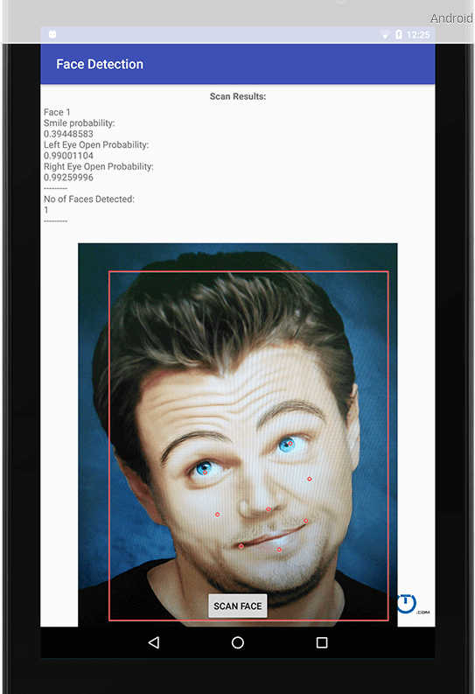

Pair – sharing Activity #2:
Our next project is the attendance app using facial recognition API.

